01 Project Information
Sri Gowtham CBSE School, Malkipuram
TRAFFISENSE AI
An Automated AI & IoT System for Smart Traffic, Emission & Noise Monitoring
02 Theme
Traffic and Urban Mobility.
03 Swarna Andhra Sutra(s)
Sutra 6-Global Best Logistics, Sutra 9-Swachh Andhra, and Sutra 10-Deep Tech. TAFFISENSE uses AI-based monitoring to detect over-speeding, reckless driving, excessive vehicle smoke, and noise pollution. It promotes safer and more efficient transportation, supports a cleaner environment, and demonstrates the application of AI and deep technology to urban traffic and public safety challenges.
04 What is the Problem?
- Heavy Vehicle Smoke & Neglected Engines: Vehicle owners skip engine oil maintenance, emitting toxic smoke and carbon particulates on city roads.
- Illegal Silencers & Noise Pollution: Aftermarket modified silencers create deafening noise, disturbing residential and hospital zones.
- Over-Speeding & Reckless Driving: Excess speed leads to fatal accidents, while existing manual checks fail to monitor roads 24/7
- Inefficiency of Manual Traffic Checking: Traffic police cannot manually inspect every smoking or speeding vehicle on busy highways.
05 What is Your Proposed Solution?
AI Optical Smoke Detection: Road-side Al cameras powered by Computer Vision analyze the density and color of exhaust smoke emitting from vehicles in real-time.
Multi-Sensor Traffic Pole: Combines Speed Radar, Decibel Noise Sensors, and Optical Smoke Density Sensors mounted on road gantries to monitor vehicle parameters simultaneously.
Automated Penalty System: When emission or speed limits are breached, ANPR captures the license plate and instantly alerts Traffic Police and the vehicle owner via SMS.
Step-by-Step Working Mechanism: Automated Sequence from Vehicle Entry to Penalty Trigger
- Vehicle Entry passes through the Smart Pole Monitoring Zone on highway or road. DETECT
- Multi-Scan Al Camera & Sensors Scan Smoke Level, Noise Decibels & Radar Speed.
- Limit Check Microcontroller compares values against permissible legal limit thresholds.
- ANPR & Alert If exceeded, ANPR captures plate, generates proof & sends SMS e- Challan.

Component | Estimated Cost (₹)
Raspberry Pi 4 Microcontroller | 4,500
HD Wide Angle Camera Module | 1,500
MQ-135 Gas & Sound Sensor Kit | 800
Radar Speed Measurement Sensor | 1,200
GSM Module & Battery Unit | 1,500
TOTAL ESTIMATED COST | 9,500
06 Additional Information (Optional)
Hardware Components | Software Stack
Al Camera (ANPR) Captures HD photos of license plates and visual smoke | Python & OpenCV Real-time video processing and smoke analysis
MQ-135 / Optical Gas Sensor Measures carbon particulate density in exhaust | Tesseract OCR / ANPR Automatic Number Plate Recognition algorithm
Radar Speed & Acoustic Sensor Detects vehicle velocity and illegal silencer noise | IoT Cloud Server Stores violation logs and vehicle records safely
Raspberry Pi 4 / GSM 4G Module Edge processing microcontroller with cloud connectivity | Twilio / RTO Gateway API Triggers instant e-challan SMS to vehicle owners
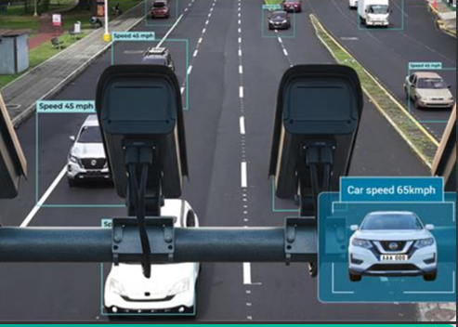
07 Team Members
Rapaka Mesheer
Choppala Sridhar
M YesuRaju

